**Film Noir with React**

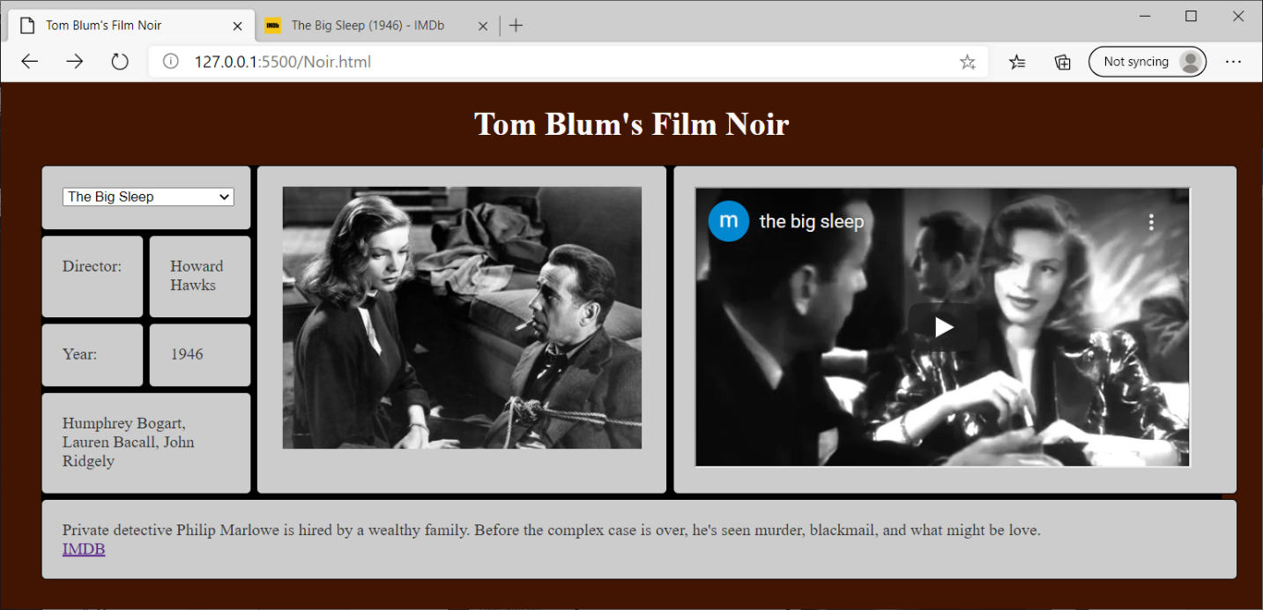

1. Use the headstart **Noir.html**. Add a title John Smith’s Film Noir (with John Smith replaced by your name).
2. Add an HTML comment with your name.
3. Your HTML elements with ids cannot have default/meaningless ids such as Button1. They also cannot refer to some previous subject – such as books, movies, etc.
4. Make the page’s background color and (font) color anything other than the default values.
5. Put a header with John Smith’s Film Noir (with John Smith replaced by your name) at the top of the page.
6. Add a div element that has the "wrapper" class that will also serve as the "target" for your react component.
7. Link to the React and possibly Babel code.
8. Place a JavaScript comment with your name at the top of the script area (which might be of the type Babel).
9. Use fetch to read the file noir.json. And use this information to set the state of your React component.
10. Use React to create nine div’s. They all should have the class “box”. The individual features of the div’s are as follows:
    1. Spans two columns and contains a drop-down select (with film titles)
    2. Has a Grid Column of 3 and Grid Row starting in row 1 and spanning 4 rows and contains an image (with a movie still). The image should have a width of 350
    3. Has a Grid Column of 4 and Grid Row starting in row 1 and spanning 4 rows and contains an iframe (with film youtube clip). The iframe should have a height of 270 and a width of 480
    4. Contains word “Director”
    5. Displays the selected film’s director
    6. Contains the words “Year”
    7. Displays the selected film’s year of creation
    8. Has a Grid Column starting in column 1 and spans 2 columns and Grid Row of 4 it should contain the film’s stars
    9. Spans four columns and displays the film’s description and a link to the IMBD page about that movie. Use target="_blank" so that the hyperlink opens a new tab .
11. The drop-down select should be loaded with film titles from the JSON file.
12. When the user changes the title in drop-down select, that film’s director, year, stars, and description should be displayed.
13. In addition, that film’s still should be displayed and a youtube clip from that film should be displayed.
14. The IMDB link at the end of the description should be updated to the selected movie.
15. A random film should be selected to be displayed at the start. This can be done as part of the fetch in the last “then” or in an additional “then”.